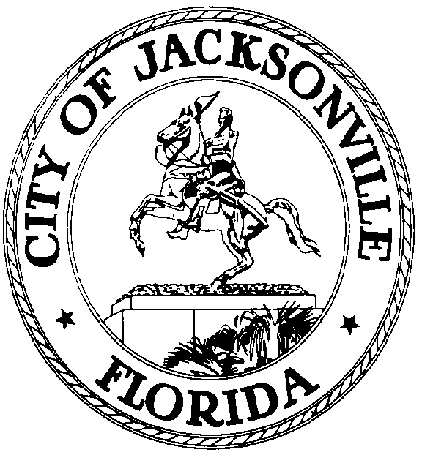

GARRETT L. DENNIS
Council Member District 9
E-Mail: GarrettD@coj.net

OFFICE OF THE CITY COUNCIL
117 West Duval Street City Hall, Suite 425
Jacksonville, Florida 32202
Office (904) 255-5209
Fax (904) 255-5230
.

MEDIA RELEASE

FOR IMMEDIATE RELEASE – June 17, 2020
Contact: Garrett Dennis (904) 887-1870

COUNCIL MEMBER GARRETT DENNIS INTRODUCES LEGISLATION TO RENAME HEMMING PARK

JACKSONVILLE, Fla. – Following the removal of the Confederate monument in Hemming Park, Council Member Dennis has introduced new legislation to rename the park James Weldon Johnson Park.

“Not only was James Weldon Johnson born and raised in Jacksonville, he has become a historic public figure, known for his famous song, ‘Lift Ev’ry Voice and Sing.’ I think this is a perfect time and way to honor Mr. Johnson, particularly at a time where everyone simply wants to lift their voices and be heard. In addition, today marks his 149th birthday. It is an honor to memorialize him through this piece of legislation,” Dennis said.

